Department of Cardiothoracic Transplantation

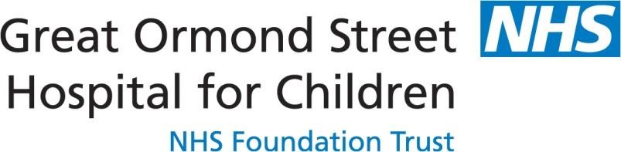

GOSH

London WC1N 3JH

Firday, 7th October 2022

To whom it may concern

**RE: Dr Richard Issitt International Pediatric Transplant Association Young Investigator Scientific Award Application**

I confirm that I fully support Dr Richard Issitt’s Fellowship IPTA Young Investigator application.

His project has created a novel treatment modality, offering patients with complex congenital heart disease a greatly increased chance of cardiac transplantation. We now have a tenable technique to offer transplantation to children who are sensitised due to operations for Congenital Heart disease due to lack of suitable donors.

This work has the potential to attenuate incidences of rejection as well as waiting times and deaths on the waiting list, that have increased dramatically over the past decade, particularly for those children with high levels of anti-HLA antibody, for whom a suitable donor is unlikely.

This project, draws on the expertise and success of a similar succesful project, within the GOSH perfusion department, to remove blood group antibodies during cardiac by-pass has revolutionised ABO incompatibility transplants. This work has recently been featured on media outlets and is being implemented at cardiac centres across the globe. This project has the potential to do the same for those recipients for whom a heart transplant is currently unlikely due to high levels of HLA antibodies.

I can confirm that Richard is an allied health professional and within his British Heart Foundation Fellowship.

Yours faithfully,



Dr Matthew Fenton MBBS BSc

Co-Director of Cardiothoracic transplant