­­­­

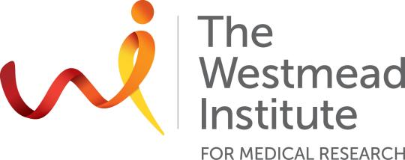

**The Centre for Transplant and Renal Research**

Centre for Transplant and Renal Research Room 05.04, Level 5Telephone: (02) 8627 3049Email: min.hu@sydney.edu.au

28th April, 2023

To Whom It May Concern:

**Re: TTS Travel Award to attend IPITA-IXA-CTRMS Joint Congress 2023**

I am writing to strongly support for Haina Wang’s application for a travel award from the TTS to attend the 2023 International Congress of The Transplantation Society to be held in San Diego, United States in October 26-29th.

Haina is a Young Investigator who has demonstrated a sustained and high level of research output throughout her early career. She was awarded First Class Honours in 2020 from University of Sydney and TSANZ Early Career Researcher Award Basic Science (2022). Ms Wang has been extremely productive relative to opportunity.

Haina’s first author abstract have been submitted including studies on islet xenotransplantation and transplant tolerance. The title of abstract is "A novel subset of memory-like CD127highCD4+FOXP3+Treg found in porcine neonatal islet cell cluster (NICC) xenotransplant tolerant mice share similar features with tissue Tregs”.

Her presence at this conference will give her an important update of transplant immunology and provide opportunities to establish important overseas collaborations. It will also enable the work carried out at Westmead to be presented to an international audience.

I have no hesitation in supporting Ms Wang in this application for financial support to attend the IPITA-IXA-CTRMS Joint Congress 2023. I hope that TTS is able to provide support to people such as Haina, who is establishing a career in transplantation.

Yours sincerely,



**Dr. Min Hu**

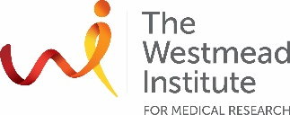Senior Research Fellow and Senior Lecturer