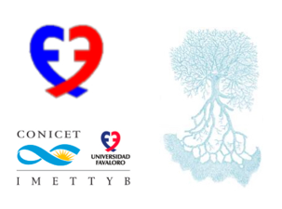

June 12th, 2024.

Dear Prof. Memeth Haberal
Chair of the TTS 2024 Congress.
Prof. Elmi Muller
TTS President.
………………………………………………………..

Jeremias E. Moreira (DNI: 37277112) is currently in his 4th year PhD student at our Microsurgery Research Laboratory - Universidad Favaloro, in Buenos Aires, Argentina. Over the year he proved to be not only a very dedicated and committed basic scientist but also a very skilful micro-surgeon, who has not only been able to learn complex transplant procedures like intestinal transplant in rodents, but also has been able to develop novel procedures like the non-vascularized abdominal rectus fascia transplant in rodents.
The fact having a veterinary career as background, was essential for him, to inbreeding a cluster of genetically modify rodents in our facilities. These animals are currently in use for different projects.

Sincerely
