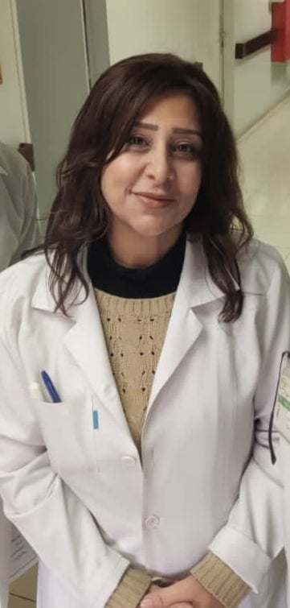

**Prof. Hala WANNOUS**

Consultant of Pediatric Nephrology.

She obtained her Master Degree in Pediatrics from Damascus University, Children’s University Hospital, Damascus, Syria, **AFSA** (Attestation de Formation Specialisee Approfondie) in Pediatrics from **Denis Diderot** **– Paris 7 University, Paris, France**, and **DIU** (Diplome Inter-Universitaire) in Pediatric Nephrology from **Rene Descartes – Paris 5 University, Paris, France.**

Prof. WANNOUS is currently Head of the Department of Pediatric Nephrology, Hemodialysis, and Kidney Transplantation at Children’s University Hospital in Damascus, Professor-Faculty Member in Faculty of Medicine – Damascus University.

She is the chairperson of the scientific committee of the Syrian Society of Nephrology and Hypertension, and the representative of the Syrian Society of Nephrology and Hypertension at the Middle East Regional Board of the International Society of Nephrology (ISN).

Prof. WANNOUS is a speaker at national and international meetings.

She has also published articles in the field of pediatric nephrology in peer-reviewed journals.