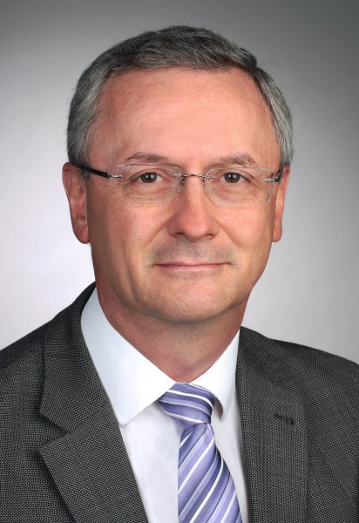

Professor Edward K. Geissler, PhD
Head of Experimental Surgery
Department of Surgery
University Hospital Regensburg
Franz-Josef-Strauss-Allee 11
93053 Regensburg, Germany
Tel.: +49 941 944 6961 (Sec.)
Fax: +49 941 944 6739
E-mail: edward.geissler@ukr.de
ORCID ID: https://orcid.org/0000-0003-3661-6168

Edward Geissler is a scientist at the University of Regensburg working in different areas spanning the field of Transplantation including basic immunology and tolerance, solid organ transplantation, immunosuppressive therapies and post-transplant malignancy. He has focussed on the understanding and prevention of immunologic rejection of transplanted organs and on novel, as well as conventional, immunosuppressive therapies to prevent transplant rejection. He also has an interest in post-transplant development of cancer, and has made a strong translational research effort through clinical trials to reduce the threat of malignancies in transplant recipients. In another effort to reduce the burden of immunosuppressive drugs, he has lead an international initiative to introduce different immune cell therapies in transplant recipients, called The ONE Study. Transfer of new ideas from basic research to the transplant recipient is a central theme of his work. He is also an Executive Editor of the TTS journals, Transplantation and Transplantation Direct.

