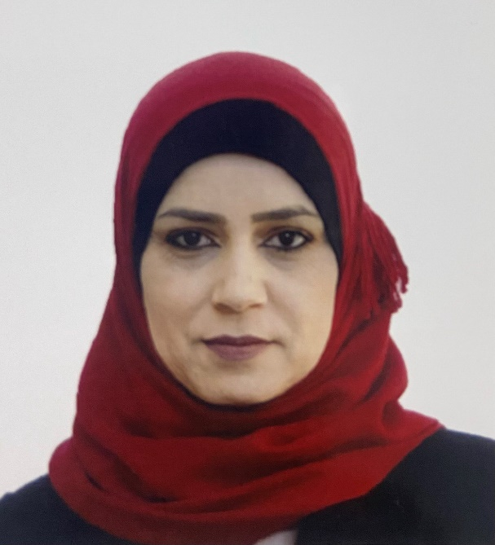

**Huda Al-Taee** is a Nephrologist at Nephrology and Renal Transplantation Center, The Medical City, Baghdad- Iraq.

In 2005, she got her M.B.Ch.B. from Baghdad Medical College. She finished her residency in teaching hospitals and had her Arab Board Certificate in Internal Medicine in 2015. In 2019, she got the Iraqi Board Certificate in Nephrology and Renal Transplantation. In 2021, she became a Fellow of the American Society of Nephrology and earned the Arab Board Certificate in Nephrology and Renal Transplantation in the same year. She is interested in renal transplantation and transplant immunology and published research in kidney transplantation.