**Professor /Mohamed Hany Hafez**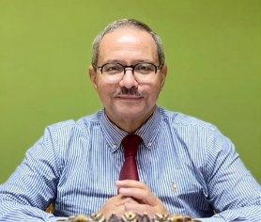

**• Graduated 1979 Cairo University.Training in Nephrology, Necker,Paris 1992--Boston USA 1998 --Spain 2014 and 2017 -Emeritus Professor of Medicine and Nephrology –Cairo University Egypt from 2015 till now. Supervised numerous masters and doctorate theses in nephrology in Egypt.External Examiner in Many Nephrology Examination for Boards in Middle East and Africa (eg Jordan, Iraq ,Sudan and Ethiopia) -Received many national and international awards in education, including the Global Kidney Academy in 2011**

**• Past President Egyptian Society 0f Nephrology & Transplantation (ESNT)2018-21**

**• Chief of nephrology Councils of Egyptian and Arab boards -Regional Councilor DICG**

**• Secretary General of Middle East Society of Organ transplantation ( MESOT )**

**• President Of African Society of Nephrology (AFRAN)**