PROFILE UNIVERSITY OF CHICAGO 
_____________________________________________________________________

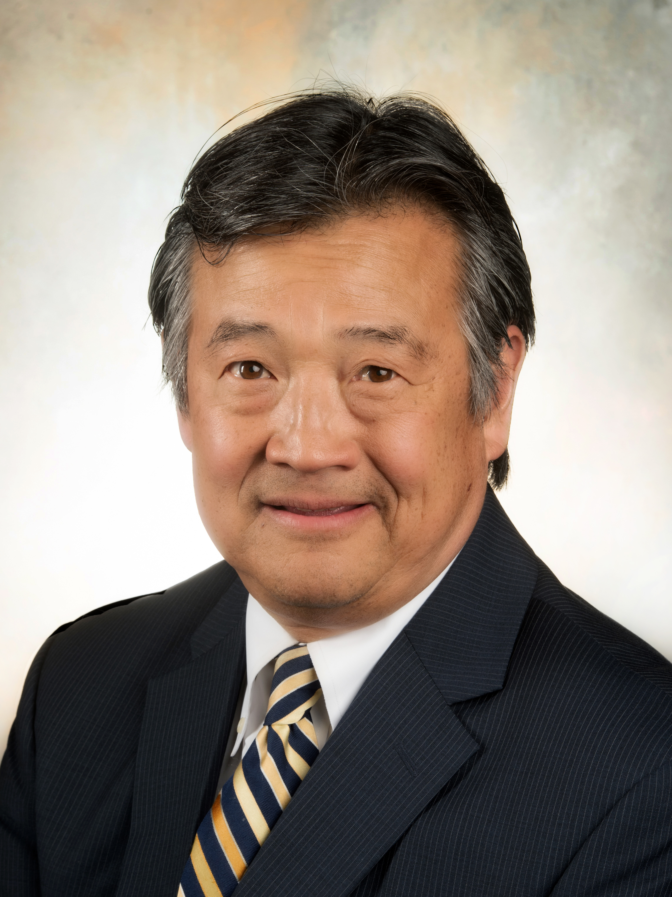
John J. Fung, MD, PhD
Director, UChicago Medicine Transplantation Institute
Professor of Surgery
President-Elect, Transplantation Society

John J. Fung, M.D., Ph.D. is the Director of the UChicago Medicine Transplantation Institute. Prior to that, he served as Chairman of the Cleveland Clinic Health System Center for Transplantation, as well as the former Chief of the Division of Transplant Surgery at the University of Pittsburgh. With 40 years of involvement in abdominal and cellular transplantation, he is also an accomplished immunologist.

Dr. Fung received his B.A. from the Johns Hopkins University in 1975, followed by a Ph.D. in Immunology in 1980 and M.D. in 1982 from the University of Chicago. He completed his surgical residency at the University of Rochester, and a transplant surgery fellowship at the University of Pittsburgh, under the guidance of Dr. Thomas Starzl. Between 1987 and 1988, he served as Director of Histocompatibility Testing at the University of Rochester. In 1989, he joined the faculty at the University of Pittsburgh and held the tenured position as the inaugural Thomas E. Starzl Professor in Surgery. He joined the Cleveland Clinic as the Chairman of the Department of Surgery and Chairman of the Digestive Disease Institute. He was also Professor of Surgery at the Lerner College of Medicine at Case Western University. He also served as the Medical Director of Allogen Laboratory, one of the largest histocompatibility laboratories in the United States and oversaw transplantation services at five Cleveland Clinic facilities globally. In 2016, he was recruited to serve as the Director of the newly created University of Chicago Medicine Transplantation Institute.

Dr. Fung is a member of numerous scientific and surgical societies and served as President of the International Liver Transplantation Society from 1997-1999. He is currently President-Elect of the Transplantation Society. He has published over 1,400 articles and book chapters and serves on the editorial board for several medical journals. He is the past Editor-in-Chief for Liver Transplantation, the highest impact factor specialty transplant journal. His principal research interests are in transplantation immunology, immunosuppressive therapies, and liver related immunology. In addition, he has received numerous prestigious lay and professional awards. His research interests are in transplant immunology, liver immunity, immnosuppression, and outcomes analysis.

Dr. Fung is active in community affairs and has been a member of the Board of Directors at the Americans for Medical Progress and the Gift of Hope Organ Procurement Organization. He received an honorable discharge from the United States Army Reserve Medical Corps with the rank of Lieutenant Colonel. He and his wife, Beth have four children: Justin, Lauren, Brendan and Shannon.

