Arnold I. Caplan, Ph.D.  Case Western Reserve University, Cleveland, Ohio  ▪Director, Skeletal Research Center  ▪Professor, Departments of Biology (Primary Appointment); General Medical Sciences (Oncology); Pathology and Biomedical Engineering (Secondary Appointments) | 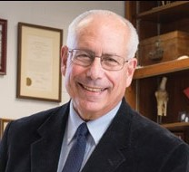

Arnold I. Caplan, Professor of Biology and Director of the Skeletal Research Center at Case Western Reserve University. He received his Ph.D. from The Johns Hopkins University School of Medicine. Dr. Caplan is a national and international scholar focusing on experimentation in the area of musculoskeletal and skin development. He has published over 490 papers and manuscripts and has long been supported by the NIH and other non-profit and for-profit agencies for his efforts in trying to understand the development, maturation and aging of cartilage, bone, skin and other mesenchymal tissues and for his pioneering research on Mesenchymal Stem Cells.

