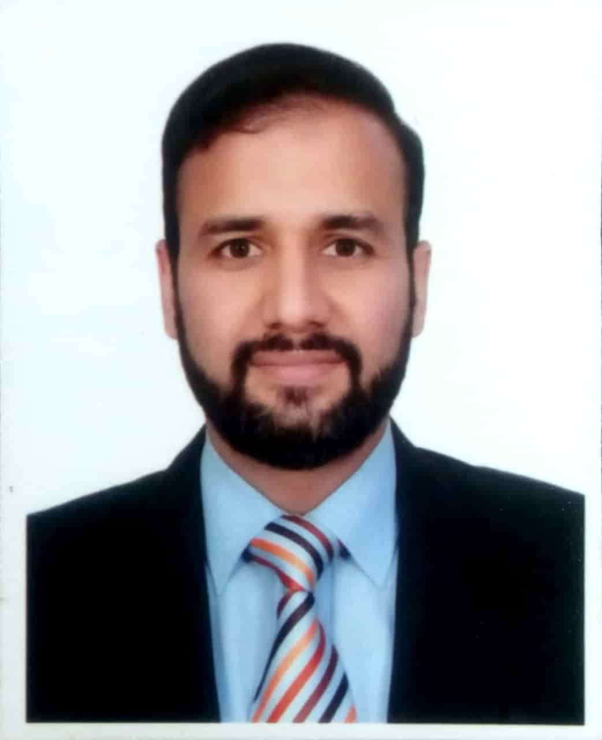**Curriculum Vitae**

**Personal Information**

|  |  |
| --- | --- |
| Name  Date of Birth  Marital Status  Nationality  Permanent Address | Dr. Muhammad Sajid Rafiq Abbasi  12-02-1975  Married  Pakistani  H. No. PD 1092 Stadium Road, Abbasi Abad, Rawalpindi  Cell # 0336-6999980  E-mail: [drsajidabbasi@gmail.com](mailto:drsajidabbasi@gmail.com) |

|  |  |  |
| --- | --- | --- |
| MRCP Nephrology/  Specialty Certification Examination Nephrology  FRCP Glasgow UK  M.D  NEPHROLOGY | 2020  2020  2013 | Royal College of Physician of UK & ERA/EDTA  Royal College of Physician & Surgeon Glasgow  Quaid-e-Azam University, Islamabad  (Pakistan Institute of Medical Sciences) |
| MRCP  (IRELAND) | 2011 | Royal College of Physician of Ireland |
| MRCPS  (GLASGOW UK) | 2011 | Royal College of Physician & Surgeon Glasgow UK |
| MD | 1999 | First Saint Petersburg State Medical University, Russia |
| FSC | 1992 | Federal Board Islamabad |
| Matriculation | 1990 | Federal Board Islamabad |

**Qualification**

**Experience**

|  |  |
| --- | --- |
| 17.06.23 till date  25-01-2022 till 16.06.23 | Associate Professor Nephrology, Pakistan Institute of Medical Sciences Islamabad  Assistant Professor Nephrology, Pakistan Institute of Medical Sciences Islamabad |
| 20-05-2019 to 24-01-2022  12-09-2012 to 19-05-2019 | Associate Professor Nephrology  Fazaia Medical College/Consultant Nephrologist PAF Hospital    Assistant Professor Nephrology  Federal Medical & Dental College, Federal General Hospital, Islamabad (FMDC)  Associate Physician( Medicine and Allied) Federal General Hospital, Islamabad |
| 20-03-2007 to 2011 (4 years) | Post Graduate Resident  (MD Nephrology)  Pakistan Institute of Medical Sciences, Islamabad |
| 01-10-2005 to 31-10-2006 (1 year) | Resident Accident & Emergency  Alsahan Bani Saad General Hospital, KSA |
| 01-03-2005 to 31-05-2005 (03 months) | Emergency Physician  Shifa International Hospital |
| 01-10-2001 to 31-05-2004 (2 years, 6 months) | Resident Internal Medicine  Pakistan Institute of Medical Sciences, Islamabad |
| 01-09-2000 to 01-03-2001 (6 months) | House Officer Cardiology  Pakistan Institute of Medical Sciences, Islamabad |
| 01-03-2000 to 01-09-  2000 | House Officer General Medicine  Rawalpindi General Hospital |

**Publications**

1.Spectrum and Short Term Outcome of Pregnancy related Acute Renal Failure among Women Admitted in Nephrology Ward; Pakistan Institute of Medical Sciences

Annals of PIMS

Ann. Pak. Inst. Med. Sci. 2011; 7(2): 57-61

2.Effectiveness of DOTS in patients with Tuberculosis Registered at Federal General Hospital Islamabad

Annls of PIMS

Ann. Pak. Inst. Med. Sci. 2017

3.Identifying the risk factors for Typhoid fever among the residents of rural Islamabad

Pakistan journal of Medical research council

[Pak J Med Res](https://www.pakmedinet.com/PJMR) Apr - Jun 2017;56(2):48-51

4.Proportion of unrecognized depression among patients attending medical patient department, Federal General Hospital, Islamabad

Health Services Academy Journal Islamabad

Pakistan Journal of Public Health| Vol. 7, No. 2| June 2017

5.Factors Associated with Treatment Compliance in Hypertension at a

Secondary Health Facility in Islamabad

Pakistan journal of Medical research council PJMR)

[VOL. 58 NO. 3 (2019): PAKISTAN JOURNAL OF MEDICAL RESEARCH](https://www.pjmr.org.pk/index.php/pjmr/issue/view/1)

6.MRSA nasal carriage: A comparison between health care workers and community individuals

Rawal medical journal

[RMJ](https://www.bibliomed.org/?jtt=0303-5212). 2019; 44(4): 679-682

7.Prevalence of Antenatal Depression Among Pregnant Women;  
A Cross Sectional Study in Tertiary Care Hospital Islamabad, Pakistan

journal of Saidu of Medical college Swat. 2021;11(2): 68-72

8..Etiology and Outcome of post-partum acute kidney injury: ”A hospital based cross sectional study”

Medical Forum Monthly

July 2021

9..Acute kidney injury in patients hospitalized with COVID-19 at tertiary care hospital Islamabad

Medical Forum Monthly

19 august 2021

10**.** Association between Pain, Functional Impairment and Radiographic Findings in Patients with Osteoarthritis of Knee

9, SEP 2021 Pakistan Journal of Medical and Health

11 contraception counseling: An addressed issue of Post Renal transplant women of reproductive age

August 2022. Pakistan Journal of Medical and Health

12. Comparison of Sofosbuvir Plus Daclatsvir with Sofosbuvir Alone in Achieving SVR In Dialysis Dependent Chronic Hepatitis C Patients

Journal of Pharmaceutical Negative Results ¦ Volume 14 ¦ Regular Issue 03 ¦ 2023

13.The Comparative Effects Of Atorvastatin And Rosuvastatin On Renal Function In Patients With Diabetes

Journal of Pharmaceutical Negative Results ¦ Volume 14 ¦ Regular Issue 03 ¦ 2023

**14;** EFFECT OF ALLOPURINOL VERSUS SALINE HYDRATION IN PREVENTING CONTRAST INDUCED NEPHROPATHY

https://www.neuroquantology.com/open-access/EFFECT+OF+ALLOPURINOL+VERSUS+SALINE++HYDRATION+IN+PREVENTING+CONTRAST++INDUCED+NEPHROPATHY_546/

15. Pattern of Biopsy-Proven Renal Dysfunction in Pakistan: A Single Center Experience

J Islamabad Med Dental Coll. 2023; 12(2): 103-109

*DOI: https://doi.org/10.35787/jimdc.v12i2.782*

16. Meta-Analysis on the Efficacy of High-Dose Statin Loading Before Percutaneous Coronary Intervention in Reducing No-Reflow Phenomenon in Acute Coronary Syndrome Am J Cardiol  2023 May 15;195:9-16.  doi: 10.1016/j.amjcard.2023.02.024.

17. Assessment of renal function and prevalence of acute kidney injury following coronary artery bypass graft surgery and associated risk factors: A retrospective cohort study at a tertiary care hospital in Islamabad, Pakistan.

Rafiq Abbasi MS, Sultan K, Manzoor R, Nizami AA, Ullah N, Mushtaq A, Saleem H, Umaira Khan Q, Akbar A, Khan Jadoon S, Tasneem S, Saleem Khan M, Alvi S.

Medicine (Baltimore). 2023 Oct 20;102(42):e35482. doi: 10.1097/MD.0000000000035482. PMID: 37861475; PMCID: PMC10589541.

18: Brain natriuretic peptide in acute heart failure and its association with glomerular filtration rate: A systematic review and meta-analysis.

Mughal HB, Majeed AI, Aftab M, Ubaid MF, Zahra S, Abbasi MSR, Qadir M, Ahmad M, Akbar A, Tasneem S, Jadoon SK, Tariq M, Hussain S, Khandker SS, Alvi S.

Medicine (Baltimore). 2024 Feb 23;103(8):e36933.

doi: 10.1097/MD.0000000000036933. PMID: 383

Top of Form

Bottom of Form

**Supervisorship:`**

FCPS Nephrology Supervisor

MD Nephrology Supervisor

**Presentations in conferences:**

1.Study abstract 'Time to change our diagnostics to win the battle against TB in Paksitan was accepted and presented by me as oral presentation at '18th International Congress on Infectious Diseases' which will be held in Buenos Aires, Argentina March 1 - 4, 2018.

2.Abstract accepted for poster presentation “Methicillin resistant staphylococcus aureus(MRSA) nasal carrier among health care workers as compared to community “ at  2018 International Conference on Emerging Infectious Diseases (ICEID 2018), which was held in Atlanta, Georgia, USA, August 26-29, 2018, at the Omni Atlanta Hotel at CNN Center.

**Memberships of professional societies**

* Member Royal College of Physicians Ireland
* Member Royal College of Physicians Glasgow UK
* Fellow Royal college of Physicians
* Member American College of Physicians
* Member American College of Nephrology
* Fellow Pakistan Society of Nephrology

**Practical Skills**

* CVP Line Insertion
* Double Lumen Catheter Insertion
* Peritoneal Dialysis
* Hemodialysis
* Renal Biopsy
* Renal Transplant
* Permanent DLC insertion
* Renal transplant work up/ post-transplant management

**References:**

* **Prof. Sameeh J. Khan**

MBBS, MD (USA), FACP (USA)

American Diplomat of Medicine

American Diplomat of Nephrology

Ex-Prof. of Nephrology, PIMS, Islamabad

Ph # 0322-5025362

Email: [sameehkhan@hotmail.com](mailto:sameehkhan@hotmail.com)

Raufniazi62@gmail.com

* **Prof. Dr. Ghias-ud-Din Butt**

MBBS, MD (USA), MRCP (UK)

Prof & Head of Nephrology PIMS, Islamabad

Ph # 0016476484429

Email: g-butt@hotmail.com

**Prof. Dr. Rauf Niazi**

MBBS, MRCP (UK), FRCP (UK)

FACP (USA), FACE (USA), FCPS (PAIC)

Chairman / Head of Department of

General Medicine & Endocrinology

Professor of General Medicine

PIMS Islamabad

Ph# 0300-8544122

Email: [niazi62@hotmail.com](mailto:niazi62@hotmail.com)