**Curriculum Vitae**

**Name;** In Sung Moon, M.D., Ph.D., FACS 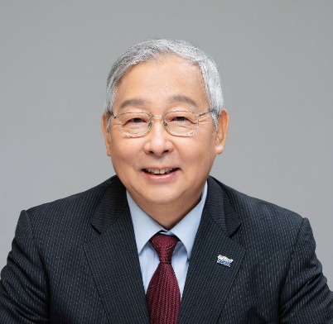

**Date of Birth;** March 22, 1955

**Present position;**

Emeritus Professor, Dept. of Surgery, College of Medicine,

The Catholic University of Korea, Seoul, Korea

Past President, Korea Organ Tissue Donation Agency (KODA)

**Office;**

**Web site;**

**Tel.)** Mobile phone) 010-8003-4639

010-7225-4290 **e-mail)** ismoon@catholic.ac.kr

**Certification;**

M.D.; Licence No. 20141, Korea(1979)

Board of Specialty; No. 1895, General Surgery, Korea(1984)

**Medical School;**

Feb. 1979; Graduate from College of Medicine,

The Catholic University of Korea, Seoul, Korea

**Medical Society;**

Oct. 1996; Fellow of American College of Surgeon. (FACS)

Oct. 1999; Secretary, The Korean Society for Transplantation

2015.10 – 2016.10; President, The Korean Vascular Surgery Society

2017.10 – 2018.10; President, The Society for Transplantation.

**Careers;**

Mar. 1984 - April 1987;

Medical Officer in Korean Navy, Staff Surgeon, Dept. of Surgery, Capital Armed Forces General Hospital, Seoul, Korea

May 1987 - Feb. 1991;

Clinical Fellow, Vascular and Transplantation Division, Dept. of Surgery, Catholic University Medical College, Seoul, Korea

Nov. 1991 - Oct. 1992 ;

Research Fellow, Dept. of Vascular Surgery. University of Pittsburgh, PA, U.S.A

Mar. 2000 -- ;

Professor of Surgery, Seoul St. Mary's Hospital, College of Medicine, The Catholic Univ. of Korea

April 2006 – Aug. 2007 ;

Chief, Organ Transplantation Center and Tissue Bank, Kangnam St. Mary’s Hospital.

Mar. 2009 -Nov. 2016 ;

Chief, Division of Vascular and Transplantation, Dept. of Surgery, Seoul St. Mary's Hospital.

Dec. 2016 – Aug. 2020 ;

Professor of Surgery, Seoul St. Mary's Hospital, College of Medicine, The Catholic Univ. of Korea

Nov. 2020 – Mar. 2024 ; :

President, Korean Organ and Tissue Donation Agency, Seoul, Korea

**References;**

Top Articles, Since 2005 (publication date of the domain article), in the Domain of Article 15848640, by BioMedUpdater LLC, Charlottesville, VA 22905-9998.

Moon IS, Kim DG, Lee MD, Hong SK, Park SC, Oh DY, Ahn ST, Lee YJ: A new venous conduit utilizing the recipient portal vein branches for segment V in adult partial liver transplantation. Transplant Proc; 2005 Mar;37(2):1117-8,

And 230 medical papers were published.