BIOGRAPHIC SUMMARY
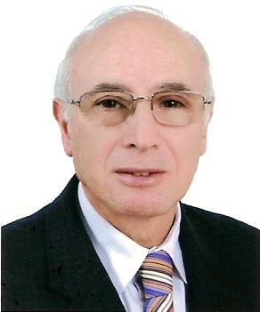
Mohamed Aziz EL MATRI, born on September 19, 1943 in Tunis (Tunisia),
Married , four children.
Present positions -Chairman of Tunis Dialysis Centre
-President of Dialysis Centres Owners Union
-Vice president and founder of the Tunisian Kidney Foundation. - Member of the Kidney Committee at the Ministry of Health. - Member of the Scientific Committee of the National Centre for Organ Transplantation
-President of the Tunisian Society of Telemedicine and e-Health
-President of the Arab Society of Telemedicine and e-Health.
-National member of the International Society for Telemedicine and e-Health.
- Societal Dialogue for Health group coordinator
-Past president of Tunisian Society of Nephrology ,Dialysis and Transplantation(STNDT)
-Past president the African Association of Nephrology (AFRAN)
-Past president of Arab Society of Nephrology and Renal Transplantation (ASRNT)
-Past president of Middle East Society of Organ Transplantation(MESOT).
Honours
- Medal of Health, Republic of Tunisia.
-Honour Medal of the Tunisian Medical Council - Honour Medals of the Tunisian Society of Nephrology and of other national and regional medical societies.

