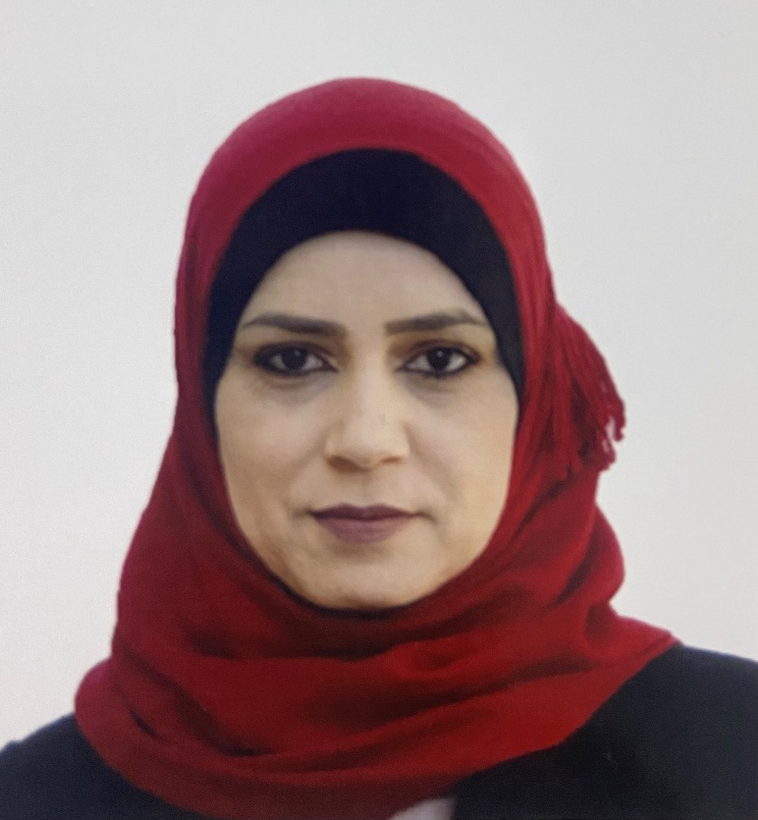 |  | huda al-taee  Nephrologist  FASN, FIBMS-Nephrology, CABM-Nephrology
Personal information  Date of birth: 21st Dec 1981  Place of birth: Baghdad, Iraq  Citizenship: Iraq  Languages: English, Arabic  Contact  PHONE:  +9647707894586  EMAIL:  hd_altaee@yahoo.com  hudaaltaee81@gmail.com |  | education/post-graduate training  Medical school: College of Medicine/ University of Baghdad 2005  Residency:  Al-Eylwia teaching hospital Jan 2006 - Jul 2006  Al-Kindy teaching hospital Jul 2006 - Jul 2009  Senior House officer-Department of Internal Medicine:  Al-Diwanya teaching hospital Jul 2009 - Apr 2010  Al-Noor general hospital Apr 2010 - Oct 2010  Fellowship:  Arab Board of Internal Medicine Oct 2010 - Oct 2015  Iraqi & Arab Board of Nephrology Oct 2016 - Oct 2019  The Medical City Teaching Hospital – Baghdad  Clinical Transplant Fellowship Jan 2021- Dec 2022  Medical licensure: 35388 Nov 2005 Baghdad- Iraq  Board Certification:  Arab Board - Internal Medicine Oct 2015  Iraqi Board- Nephrology Oct 2019  Arab Board- Nephrology March 2021  Other Degrees:  Fellow of American Society of Nephrology Jan 2021  Diploma of Internal Medicine May 2015  SOCIETY MEMBERSHIPS  - American Society of Nephrology - July 2017  - Iraqi Society of Nephrology and Renal Transplantation – Oct 2017  - ERA- EDTA - Dec. 2018  - International Society of Nephrology – Dec 2018  - American Society of Transplantation – Dec 2019  - European Society for Organ Transplantation – Dec 2019  - The Transplantation Society - March 2020  - National Kidney Foundation - March 2020  - Middle-East Society of Organ Transplantation- Jan 2021  LECTURES/PRESENTATIONS GIVEN AT LOCAL MEETINGS  - Nov 14, 2019 Nephrology and Renal Transplant Education  Recurrent FSGS post kidney transplantation, case presentation and Review.  - Dec 1, 2019, Nephrology and Renal Transplant Education  Facts about Anti PLA2R review article.  - Dec 10, 2019, Nephrology and Renal Transplant Education  Multi-target therapy for lupus nephritis.  - Dec 12, 2019, Nephrology and Renal Transplant Education Direct-acting antiviral therapy for hepatitis c viral infection in kidney transplant recipients; Review and clinical application.  - Dec 14, 2019, Nephrology and Renal Transplant Education Knowledge and Attitude Towards Organ Donation and Transplantation Among HCPs in Baghdad Medical City Teaching Hospital.  - Jan 15, 2020, Nephrology and Renal Transplant Education  Pregnant woman with lupus and nephrotic range proteinuria/ case presentation.  - Feb 25, 2020, Nephrology and Renal Transplant Education  Live donor GFR assessment and Post donation risk.  - June 27, 2020, Nephrology and Renal Transplant Education  Online meeting:2019 Updated Banff Classification of Renal Allograft Pathology.  - March 13, 2022, Nephrology and Renal Transplant Education: World Kidney Day.  - February 28, 2023, Expert meeting, case presentation. Amman, Jordan.  - July 2023, 4th kidney transplantation course, Case presentation. Istanbul-Turkey  - Jan 2024, Renal Transplantation in Iraq, Evidence-based Reflection. 2nd Congress of the Iraqi Society of Nephrology and Renal Transplantation.  CONGRESS AND COURSES  - 16th annual international conference of Jordan Society of Nephrology and Renal Transplantation-2018  - TTS Virtual Congress 2020  - AST Fellow Symposium 2020  - ASHI Educational Workshop 2020  - ASHI Virtual Congress 2020  - ESOT-TLJ2 (online) 2020  - ESOT-Hesperis course (online) 2021  - ESOT Congress (online) 2021  - 17th MESOT Congress (online) 2021  - Iraqi Society of Nephrology and Renal Transplantation Congress (1st congress) 2022  - 40th Congress of the Egyptian Society of Nephrology and Transplantation (online) 2022  - 1st Arabian society of histocompatibility and immunogenetics congress (online) 2022  - ESOT-Academia course (Rome) 2022  - 2nd Glomerulonephritis update conference (online)-2022  - TTS Congress (oral presentation) online- 2022  - 21st annual international conference of Jordan Society of Nephrology and Renal Transplantation- Amman-2023  - 18th MESOT Congress -2023  - 4th kidney transplantation course- Istanbul-2023  - ESOT Congress- Athens- 2023  - 2nd Iraqi Society of Nephrology and Renal Transplantation Congress (speaker)-2024  BIBLIOGRAPHY  - Al-Taee HA, Athab AK, Ali A. Renal phosphate loss in Iraqi chronic myeloid leukaemia patients treated by imatinib mesylate. Iraqi J Hematol 2020;9:72-6.  - Athab AK, Mohammed HA, Ali A. Serum Magnesium in a Sample of Iraqi Adults with Essential Hypertension. Iraqi Journal of Medical Sciences 2020; Vol.18(2).  - Ali A, Al-Taee HA. Knowledge and Attitude Towards Organ Donation and Transplantation Among a Sample of Iraqis in the City of Baghdad. Transplantation Sep2020, Vol 104, No.S3  - Ali AS, AL-Taee HA, Kadhim TJ. Crescentic glomerulonephritis in renal transplant; a case series. J Nephropathol.2021;10(x):exx.  - Ali AA, Al-Hashimi B, Al-Taee HA, Bahaaldan SS. Knowledge and Attitude of medically and non-medically educated persons towards organ donation and transplantation: a sample from the city of Baghdad. Experimental and Clinical Transplantation. 2021 Feb 1.  - Ala Ali, Mohammed S. Klaif, Huda Altaee. COVID-19 In Renal Transplant Recipients; A Case Series From Iraq. Nephrology Dialysis Transplantation May 2021, Vol.36, issue supplement_1.  - Ala Ali, Huda Al-Taee, Maryam S. Jasim. Adherence to Immunosuppressive Medication in Iraqi Kidney Transplant Patients during the first year of transplant. A single-center experience. Experimental and Clinical Transplantation .2022; Suppl 1: 107-112.  - Ala Ali, Huda Al-Taee, and Thaer J Kadhim. Relapsing De Novo Membranous Nephropathy. Case Reports in Transplantation. Volume 2022; Article ID 6754520.  - H Al-Taee, A Ali. Commercial Kidney Transplantation: Sociodemographic and Clinical Characteristics. Transplantation. 2022;106(9S),S93.  - Huda Al-Taee, Ala Ali. Inhibition of the Mechanistic Targets of Rapamycin Beyond Transplant Immunosuppression: A Mini-Review. Medical Research Archives. 2023;11(2).  - Huda Al-Taee. Demographic and Clinical Characteristics of Kidney Donors at First Check: A Single-Center Study from Iraq. Experimental and Clinical Transplantation (2024) Suppl 1: 229-232.  - ALA Ali, A. Alaa Ali, Huda AL-Taee A. Kidney allograft pathology during the first year of transplant. Three years data from Iraq. Kidney International Reports (2024) 9, S1–S662.  - Social and psychological profile of Iraqi living kidney donors. Accepted for poster presentation in the TTS2024  IN PREPARATION  - Women health: Pregnancy, menstruation and contraception in renal transplant recipients and live kidney donor women.  GRANTA AND AWARDS  - ESOT education global grants 2022 ( Academia course ).  ACADEMIC ACTIVITIES:  - Reviewer /Saudi Journal of Kidney Disease and Transplantation.  - Participate in reviewing ERA 2023 Congress abstracts.  - Participate in reviewing ERA 2024 Congress abstracts.

